1. File transfer between ios and webclient.--------目前IOS端不支持文件传输。
2. UserA chooses a file from his iphone and sends to UserB of webclient, the file transferring missed.
3. User B of webclient sends a file to UserA of iphone, the file address displayed on the iphone is not a link. Copy and paste to brower, gets a can’t open note.



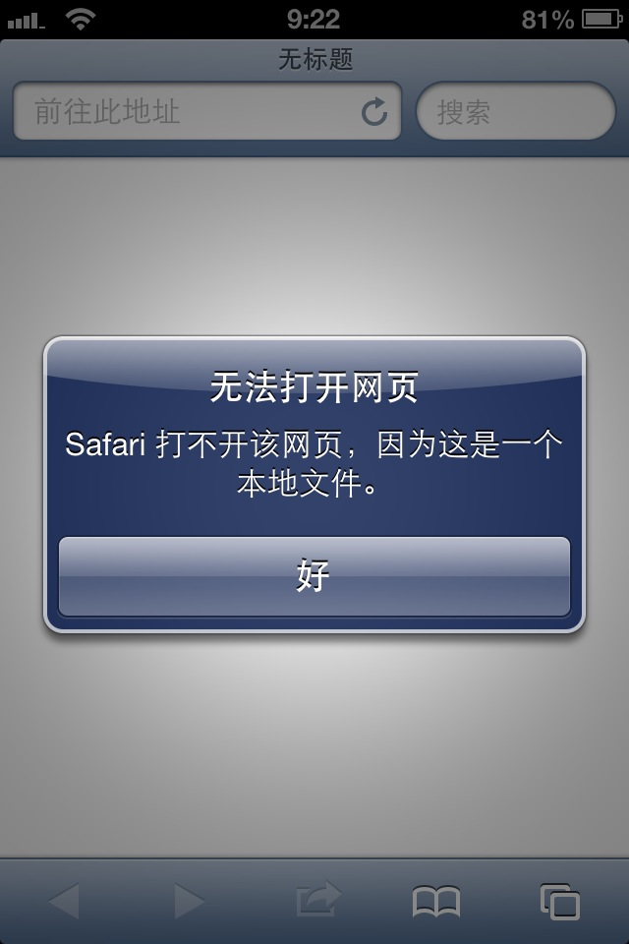

1. Webclient: in one on one chatting, the right icon of “show room members” should be changed into “profile”, and clicked to display the other person’s profile.

1.jpg